# **ON-CAMPUS SERVICE REGISTRATION APPLICATION**

**Abstract**: Our campus service registration application optimizes access to vital amenities, encompassing room maintenance, WiFi IT support, bike rentals, health counselling, and laundry services. Tailored for students and staff, it bolsters convenience and efficiency campus-wide. Simplifying room maintenance requests ensures a conducive learning environment, while prompt IT support resolves WiFi issues swiftly, enhancing productivity. Bike rentals promote sustainable transportation, facilitating easy mobility. Confidential health counselling aids in managing personal challenges effectively, fostering well-being. Laundry services streamline the process, saving time and effort in maintaining cleanliness. Together, these modules empower users, elevating the overall experience and functionality of campus life.

## **DATA-FLOW DIAGRAM**

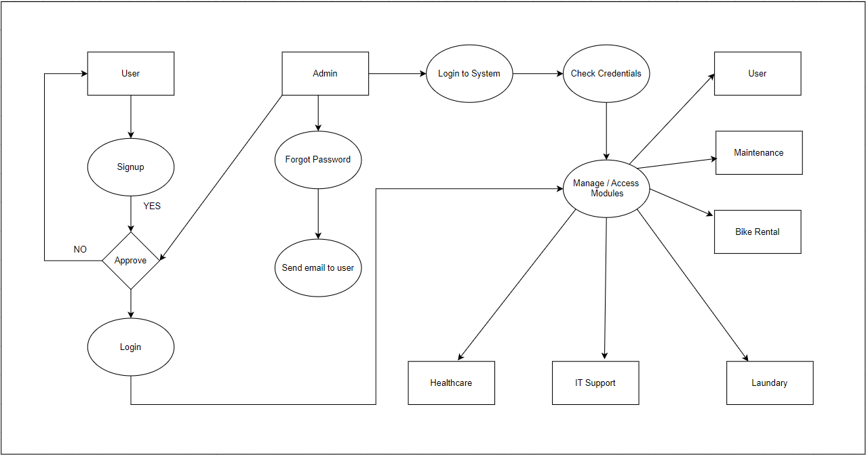

## **MODULES**

1. **Maintenance for room**: Simplifies requests for room maintenance, ensuring prompt resolution of issues to maintain a conducive living and learning environment for students and faculty.

2. **IT support WiFi:** Facilitates seamless connectivity by providing efficient IT support for WiFi services, resolving technical issues promptly to enhance productivity and accessibility for campus users.

3. **Bike rental:** Enables convenient access to bicycles for short-term rentals, promoting sustainable transportation options and facilitating easy mobility for students and staff around the campus.

4. **Health case counselling:** Offers confidential counselling services for mental health and well-being, supporting students and staff in managing stress, anxiety, and other personal challenges effectively.

5**. Laundry management system:** Provides hassle-free laundry services, allowing students and staff to conveniently submit and collect their laundry, saving time and effort in maintaining clean clothing and linens.